

**ACT AGAINST RAPE!**

**USE THE ISTANBUL CONVENTION!**

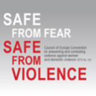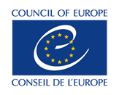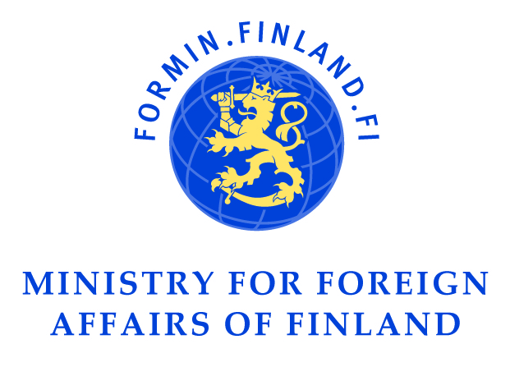With the support of the Ministry of Foreign Affairs of Finland and the Council of Europe.