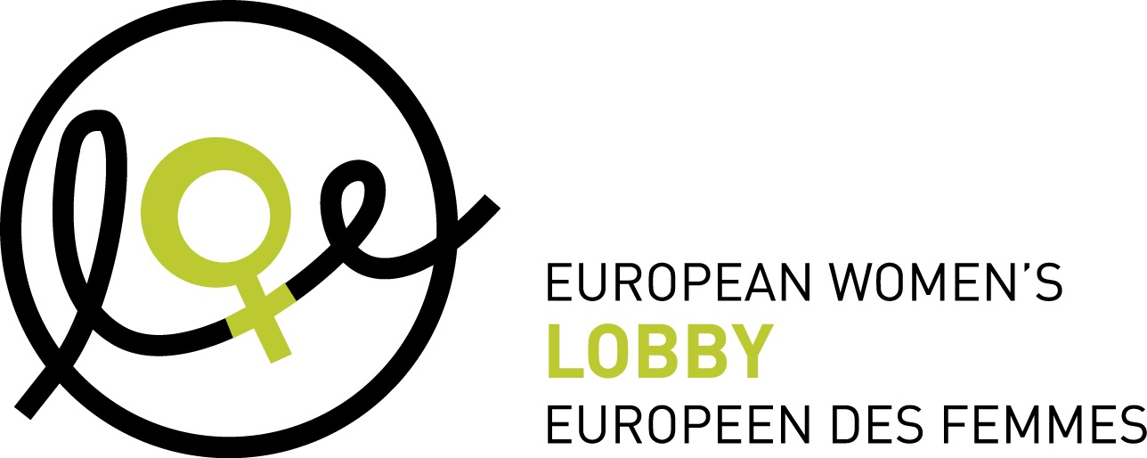

European Women’s Lobby recommendations
on the European Commission strategy on
equality between women and men 2020-2025

Together with its 2000 women’s organisation across Europe, the European Women’s Lobby recognises the reality of women and girls’ lives in Europe today and brings together the perspectives of women and girls and its membership across Europe. EWL’s priorities reflect the unfinished business of implementing international human rights instruments to advance women’s rights over the past three decades and ensure we are driving for further transformational progress.

Ensuring equality between women and men and integrating the dimension of equality between women and men in all policy and financial frameworks is an obligation of the European Union as per the EU Treaties. To promote equality between women and men as one of its core values, the EU must take concrete and tangible actions and adopt an ambitious and actionable strategy which, in accordance with the Treaties, should specifically focus on putting an end to inequality between women and men. Women’s lived experience and life circumstances should be put at the centre of this strategy to allow for specifically tailored actions to improve their lives. This should send a clear signal to women in all their diversity that the EU is ready to work for them.

Indeed, women - even though they represent more than half of the European population - are still facing many different types of inequalities solely based on the fact they are women. Gender stereotypes play a key role in perpetuating unequal power relation between women and men, in keeping women in subordinated positions in the labour market, in decision-making and in the public and private spheres, and in legitimising violence against women. All the actions of the Strategy on Equality between Women and Men, as well as all the initiatives of the European Commission, should aim at challenging gender stereotypes, as a fundamental component of gender mainstreaming and a precondition to ending inequalities between women and men. It is very important to name these inequalities and to not invisibilise the discrimination that particularly target them. This Strategy must contribute to implementing the vision of the future of Europe we want: a Europe that leaves no woman behind.
Women’s rights in Europe are at an important moment. The new European Commission led by a woman represents a critical opportunity to advance women’s rights. The new Commissioner for equality should be empowered to lead the change: a bold new European political strategy on equality between women and men needs to reflect the level of ambition this new Commission is promising. This strategy is a unique opportunity to break barriers and stereotypes faced by all women in Europe throughout their life: in their families, at school, at work, in the public sphere and in their older age.
The European Commission should ensure its strategy is consistent on internal and external actions and reflects the continuum of the inequality faced by women within and outside the EU, as per the universality principles of the Sustainable Development Goals and other commitments assumed by EU Member States at international level (like the CEDAW).

Women are not a homogeneous group and thus it is essential to look at the great diversity of their experiences, backgrounds and the issues they face. When tackling gender stereotypes, it is crucial to keep in mind generational differences as well as an intersectional perspective, since gender stereotypes are often combined with other stereotypes fueling discrimination on the basis of age, ethnicity, migration status, sexual orientation, disability, etc., and will therefore affect some women in a greater way when they have multiple identities. The European institutions should be mindful of keeping a gender lens when working on all areas of inequalities, as such policies should never be gender-neutral.

The European Commission strategy will be adopted in an important year for women’s rights with the celebration of the 25th anniversary of the Beijing Platform for Action. The EWL is calling on the EU to play a strong leadership role in shaping a better world for women and girls and to include in its strategy on equality between women and men the following recommendations.

The strategy should aim to:

Ensure institutional mechanisms for equality between women and men

Objectives:
- To ensure the dimension of equality between women and men is adopted in all actions taken by the European Commission and all European institutions, with the strategy ensuring that gender mainstreaming is present in all activities performed.
- To ground the European Commission's work on sound women’s rights expertise and allow stronger response to inequalities and robust gender mainstreaming.
- To strengthen collaboration between all EU institutions, key stakeholders, including women’s rights organisations, and Member States to improve women’s lives in Europe.

Key actions:

- Create a Task force of experts which would gather representatives from different Directorate Generals in the Commission, as for example experts on digital issues, employment, social affairs and inclusion, the economy, budgets, education, trafficking and migration and the future Coordinator on violence against women.
- Reinforce expertise on women’s rights in the European Commission, in particular within the existing Gender Unit (DG Justice) but also in other Directorates as for example to promote a pilot project on gender budgeting in DG Budget.
- Put in place an Interinstitutional Task force composed of representatives of each European institution and of key stakeholders such as NGOs, including women’s rights organisations, trade unions, etc. This task force should be consulted on the definition and the implementation of the present strategy.
- Reinstate yearly Dialogue on Equality between Women and Men (previously called “Gender Equality Dialogue”) chaired by the President of the European Commission with all Commissioners, representatives of the European Parliament, Member States, the European Council and key stakeholders as the civil society, including women’s rights organisations. This should be coupled with a compulsory training on gender equality and gender mainstreaming for all European Commissioners, tackling in particular the harmful effects of gender stereotypes on equality between women and men.
- Maintain and foster activities of the Advisory Committee on equal opportunities between women and men (hosted by the Commission with representatives of Member States and external observers). The Committee should be consulted on the strategy and keep an advisory role throughout its implementation.
- Integrate the High level group on gender-mainstreaming within these different aforementioned mechanisms.
- Continue to publish annual reports on the progress made in the implementation of the strategy and put them up for debate and opinion to the Interinstitutional Task force.
- Better use of data in the gender equality index published by the EIGE and have them integrated across the board in all the EC’s activities. This should go with mainstreaming all the efforts of the relevant EU Institutions and agencies (EIGE, FRA, EUROJUST, EASO, EUROSTAT, etc.); coordinating the efforts to enhance data collection; and facilitating the exchange of good practices for the implementation of all equality measures at the national level.
- Adopt and apply gender-budgeting methods to the EU budget and to all decisions taken on the basis of the overall budget.
- Adopt a Zero tolerance policy towards discrimination based on sex, racial or ethnic origin, religion or belief, disability, age or sexual orientation. This could be done through the adoption of a code of conduct. This policy shall ensure this protects and supports not only those women in the employment of the Institutions and agencies but also ensuring the standard of behaviour expected by all staff will not coerce, exploit or infringe on the equality of any woman or girl.

Implement gender mainstreaming to tackle stereotypes affecting women and girls and ensure the adoption of their particular perspective
Objectives
- To challenge gender stereotypes, as a fundamental component of gender mainstreaming and a precondition to ending inequalities between women and men.
- To implement gender mainstreaming into all EU policies, projects and programs in order to enshrine women’s and girls perspective into designing, decision-making and implementation processes.
Key actions
- The EU should ensure the application of gender mainstreaming, gender impact assessment and gender budgeting in all EU policies, funded projects and programs.
- For example, a gender lens must be applied when designing the European Green Deal and the Digital Single Market Strategy in order to address the specific impact these measures will have on women, to make sure their perspective is represented and to ensure their participation in decision making and implementation.
- Gender mainstreaming should be specifically applied to EU policies related to or having an impact on media, education and training:
  - Control on sexism and stereotypes in media, advertising and education should be enhanced through the adoption of an EU directive, in line with the equal treatment directive and filling the gaps of the 2004 Gender Equality Directive.
  - This legislation must follow-up on the 2015 Resolution of the European Parliament on empowering girls through education in the EU, with specific attention to the provisions tackling gender stereotypes in education and training.
  - It should provide funding for the creation, development and support of feminist studies and research and the development of training programmes on women’s rights, anti-discrimination and gender stereotypes for media and advertising professionals as well as for formal and non-formal education professionals.
  - It must ensure the collection of comparable data concerning women and the media, including on the portrayal of women from specific groups such as women with disabilities or ethnic minority women.
- Regarding the awareness-raising campaigns on gender equality and violence against women implemented by Member States with the support of the EU, actively challenging gender stereotypes should be a pre-condition for granting EU funds. The EC should ensure that civil society organisations and women’s organisations are systematically involved in all the stages of these initiatives, acting as multipliers and content advisors for media companies, and should be provided with sufficient resources to give a valuable input and contribution.

Put an end to violence against women and girls; provide peace, human security and dignity for all women and girls

Objectives:

Preventing and combating all forms of violence against women and girls including sexual exploitation; protecting and supporting victims; prosecuting the perpetrators; and addressing all the structural issues that fuel this violence should be a top priority of the EU. We must promote a society of peace and safety: all women and girls have the right to a life free from violence and free from the fear of violence. The strategy should seek to disrupt the continuum of violence and protect every woman in Europe from all forms of violence.

Key actions:

- Under the leadership of the European Commission, the EU should ratify the Council of Europe Convention on preventing and combating violence against women and domestic violence, the Istanbul Convention.
- In addition, the EU should adopt a comprehensive EU-wide strategy and an Action plan on preventing and combating all forms of violence against women in Europe, including specific legislation. This plan must include:
  - A European Commission’s proposal to add violence against women to the list of EU crimes and recognise the need to combat violence against women and girls as a common goal of the EU.
  - An assessment of the legal framework existing and needed, to ensure all women in Europe are protected from all forms of violence, including sexual exploitation. By analysing the existing responses, mapping remaining gaps and creating a follow-up action plan, the assessment should seek to create a comprehensive legal framework to tackle the continuum of violence against women.
  - A Directive on all forms of violence against women and girls including definitions of different forms of violence, encompassing intimate partner violence as per the Declaration 19 on Article 8 of the TFEU, and sexual exploitation as per Article 83 of the TFEU.
  - A review of existing legislation touching upon women’s and girls’ right to be protected against violence, as for example the EU Victims’ Rights directive 2012/29/EU, the Recast Directive and EU migration policies, to ensure compliance with the standards of the Istanbul Convention.
  - The appointment of an EU Coordinator on ending violence against women and girls. The EU Coordinator will have a strong political mandate, resources and responsibility to: coordinate the implementation of the Istanbul Convention, the EU Strategy and the implementation of the Directive on VAWG.
  - Mandatory and standardized rules in all the EU countries of common standards for data collection to ensure a coherent system for collecting statistical data on violence against women and girls in the EU.
  - The enhancement of EU-wide awareness raising campaigns to end violence against women and girls in systematic consultation and cooperation with women organisations, including the Say No stop VAW campaign.
  - Allocating significant EU funds under Horizon 2020 to develop feminist research on violence against women, including sexual exploitation and pornography and their impact on women and girls, men and boys.

Ensure all women’s equal economic independence

Objectives:
- Ensure that all women in Europe have equal economic rights and choices in their lives.
- Strive towards an equal-earner-equal-carer model as opposed to a male-breadwinner model.
- Recognise and address multiple and intersecting discrimination faced by women with disabilities, from different ethnic minorities, of different socio-economic and educational backgrounds and younger or elderly women, whose access to services, decent work and funding is especially limited, and whose contributions are all too often overlooked, and whose right to independence and dignity is often not enforced.

Key actions:
- Shift towards an equal-earner-equal-carer model through:
  - Expanding the child guarantee to a ‘care guarantee’ to address care needs throughout the life-cycle (going beyond the Barcelona targets), and investing in the care economy by directing investments in the EU budget in this area.
  - Introducing EU binding legislation to address the gender pay gap including pay transparency, mandatory pay audits, part-time work, public procurement and work of equal value. .
  - Introducing a 5-10% annual target to reduce the gender pay gap and address the current gender pension gap.
  - Monitoring and reporting (annually) on the implementation of the Work-Life-Balance Directive.
- Ensure that the macro economic framework, including the post-Europe 2020 Strategy and European Semester architecture, specifically seek to progress equality between women and men and in particular women’s economic independence, in carrying out gender impact assessments of macro-economic policies prior to issuing country-specific recommendations.
- Within the framework of EU legal obligations under Article 153 TFEU on equal opportunities and equal treatment in matters of employment and occupation, and within this framework of Article 157 TFEU that authorises positive action to empower women, the EU commit to gender mainstreaming within the EU Digital Single Market strategy, specifically on closing the digital gender employment and training gap.

Promote equality in decision-making and leadership

Objectives:
- Ensure the leadership and decision-making organs of the EU comprise of feminist women from all backgrounds, representing the huge diversity of European citizens.
- Achieve parity between women and men in all European institutions and the Member States.

Key actions:
- The European Commission and the Council of the European Union reopen the process of adopting the Women on Boards Directive.
- The EU should utilise the Directive on women on boards as a tool to push for more women on the boards of public institutions and entities such as technology giants and large companies, SME’s, financial institutions, judiciary and cultural and sport bodies such as media organisations.
- Adopt binding texts to ensure parity at all level within the European institutions and agencies and encourage Member States to adopt legislation ensuring equal representation of women in decision-making.

Ensure resources for women’s rights

Objectives:
- Increase the share of EU funding to achieving gender equality, which has declined over the last decade.
- Apply gender mainstreaming to the MFF and the annual budget.
- Develop a long-term strategy on gender budgeting as a tool of gender mainstreaming.

Key actions:

- Implement gender budgeting as a tool of gender mainstreaming to ensure that all EU money is delivering on equality between women and men, including in the MFF. This could be launched through a pilot project led by a team of gender budgeting experts.
- When drafting their individual budgets, EU institutions and bodies should clarify the gender equality impact of their spending targets and define a specific gender equality objective for each budgetary item.
- Ensure sufficient and earmarked budget allocations on ending violence against women and girls, within the Daphne and AMIF strands, and sustainable funding for specialised civil society organisations providing support to women and girls victims of violence.
- Increase resources designated for support to women’s organisations both inside the EU and in the external actions of the EU.
- Ensure adequate resourcing to maintain the sustainability and resilience of the European Women’s Lobby which represents women’s organisations across the EU and is the essential civil society interlocutor of the EU institutions on Women’s Rights

European Women’s Lobby, Rue Hydraulique 18, 1210 Brussels - Belgium
www.womenlobby.org #WomenForEurope @EuropeanWomen
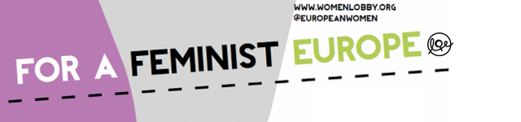
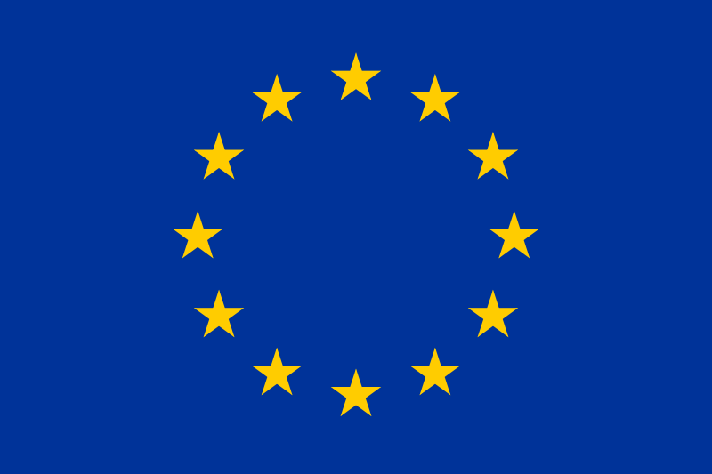 Funded by the Rights, Equality and Citizenship Programme of the European Union.

