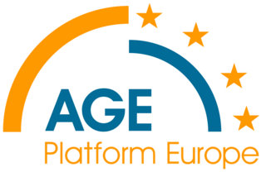 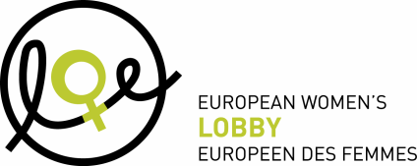

**JOINT PRESS RELEASE** Brussels, 7 March 2012

**International Women’s Day 2012:**

**The proposed reforms in social protection are going to deepen the gender gap in old age income!**

On the eve of International Women’s Day and on the occasion of the EP Interparliamentary Committee meeting on 8 March on ‘Equal Pay for Work of Equal Value’, AGE Platform Europe and the European Women’s Lobby join forces to call for strong measures to meet the needs of older women in light of current reforms in social protection systems particularly with regards to pensions. “*Calling for equal pay for work of equal value is important but not enough to ensure that women also enjoy equal rights to a fair and decent pension income. The gender pay gap and the gender pension gap are two sides of the same coin,* stressed Cécile Gréboval, Secretary General of EWL. *We must look at a care credit system which takes into account time spent outside of the labour-market for caring responsibilities for the benefit of the whole of society*. *Both women and men must be able to be workers and carers at different moments in their lives without being sanctioned in old age*”, she said.

EU leaders are increasingly pushing to align effective retirement age with life expectancy. While most countries are increasing the number of years to contribute to a full pension, little is done to compensate for the career breaks mostly taken by women take to care for dependent relatives.

*“With the on-going drastic cuts in subsidised child and eldercare services, the burden of informal care on women will increase and women will face even greater difficulties to build adequate pension rights. This will aggravate the gender gap in old age income*”, warned Anne-Sophie Parent, Secretary General of AGE Platform Europe, adding “t*he European Union has a key role in this field and its proposal for legal provisions on carers’ leave at EU level is most needed”.*

Older female workers today face additional risks of poverty in old age as a result of the strengthened link between pension contributions and benefits. Unless transitional measures are introduced to avoid blaming these women for the career breaks they took to raise their children when no alternative was available, the gender gap in pensions will increase very severely for these cohorts.

Another detrimental trend for gender equality is the increasing reliance on supplementary pensions to ensure an adequate replacement rate. This again will lead to a greater risk of poverty in old age if nothing is done to address the discrimination that women suffer in these schemes due to various reasons, including women having lower incomes, labour market segmentation, unequal pay and uncompensated career breaks for time spent out of the labour market caring for dependents.

Europe's economic recovery depends on its ability to make the best use of its human capital. When reforming their employment, pension and care systems, Member States must ensure that all together their systems will contribute to gender equality for all age groups and empower women to take a more active role in the labour market through age and gender-friendly labour markets and social protection systems.

END

**Note to the editor**

**About AGE Platform Europe**

**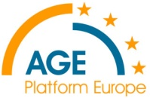***AGE Platform Europe is a European network of organisation of people aged 50+ and represents over 30 million older people in Europe. AGE aims to voice and promote the interests of the 150 million inhabitants aged 50+ in the European Union and to raise awareness of the issues that concern them most.*

[*www.age-platform.eu*](http://www.age-platform.eu)

**For more information, please contact:**

Anne Mélard

Information and Communication Officer

AGE Platform Europe

[www.age-platform.eu](http://www.age-platform.org)

Tel: +32 2 280 14 70   
Fax: +32 2 280 15 22

E-mail: [anne.melard@age-platform.eu](mailto:anne.melard@age-platform.eu)

**About the European Women’s Lobby**

*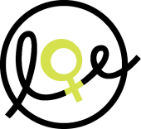The European Women’s Lobby (EWL) is the largest umbrella organisation of women’s associations in the European Union (EU), working to promote women’s rights and equality between women and men. EWL membership extends to organisations in all 27 EU Member States and three candidate countries, as well as to 20 European-wide organisations, representing a total of more than 2000 associations.*

**For further information, please contact:**   
Ms Anna Elomäki,   
EWL Communications and Media Officer  
[www.womenlobby.org](http://www.womenlobby.org)  
Tel: +32 2.210.04.27 or +32 491 64 11 35  
Email: [elomaki@womenlobby.org](mailto:elomaki@womenlobby.org),

