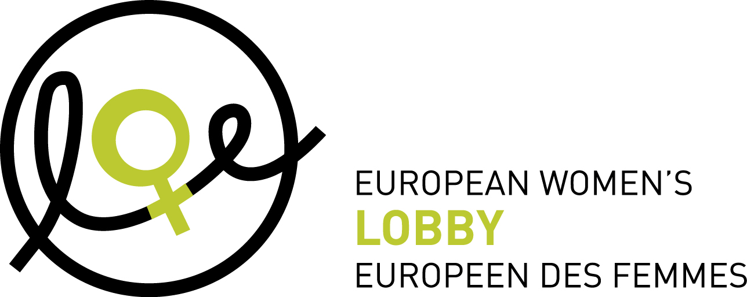

**Membership application for European-wide full member organisations of the European Women’s Lobby (EWL)**

*This application form should be filled in in all its parts and sent to the European Women’s Lobby by email (**yates@womenlobby.org**)* ***and*** *by regular mail to:*

***European Women’s Lobby (EWL)***

***18 Rue Hydraulique***

***B-1210 Brussels***

***Belgium***

*For any questions, please do not hesitate to contact the EWL Secretariat (**yates@womenlobby.org**)*

*After submitting this application form, including annexes, the EWL Executive Committee will seek the advice of the Membership Committee, and assess whether or not the candidate European-wide full member organisation is meeting the membership criteria as set out in EWL statutes.*

*The Executive Committee is entitled to ask the applicant for any additional information it deems necessary in order to issue its advice to the Board of Administration. If this body asks for any such additional information, the application procedure will be suspended until this additional information is communicated by the applicant (Art. 3 EWL Internal Rules). Additional information may also be obtained through interviews with the applicants.*

*Membership of full members takes effect following a positive vote of the Board of Administration, instructed by the Executive Committee with a two third majority of cast votes (Art. 8 EWL Statutes)*

**This form was updated by the EWL Membership Committee in 2018 and changes were approved by the EWL Executive Committee in November 2018.**

*--------------------------------------------------------------------------------------------------------------------------*

**A. General Information**

1. **Name of the candidate European-wide full member organisation (in English and in the national language, according to the Legal statute of the organisation):**
2. Legal entity number, year and place of registration of the candidate European-wide full member organisation:
3. **Contact details of the lead organisation/contact point:**

|  |  |
| --- | --- |
| Name of person responsible for this process |  |
| Email of person responsible for this process |  |
| Street and number of organisation |  |
| Postal code of organisation |  |
| City of organisation |  |
| Country of organisation |  |
| Telephone of organisation |  |
| General email |  |
| Website of organisation |  |

1. **Bank account details:**

|  |  |
| --- | --- |
| Name of account holder |  |
| Address of account holder |  |
| Account number |  |
| Name of bank |  |
| Address of bank |  |
| Code IBAN (International Bank Account Number) |  |
| SWIFT Code or BIC |  |

1. **Is the candidate European-wide full member organisation a women’s organisation?**
2. **Is the candidate European-wide full member organisation the women’s section of a mixed organisation?**
3. **Please list the organisations, sections or affiliations that are members of the candidate organisation and their addresses/contact details[1]. Note that to be a full member, the candidate organisation must be a European wide umbrella organisation of women’s NGOs with a focus on policy development within the EU, or the women’s section of a mixed European-wide organisations.**

**NOTE:** in order to be eligible for membership of EWL as European-wide organisation, the candidate must have representative organisations in at least one third of the countries in membership of the European Union, the European Free Trade Association and countries in the formal process of acceding to the EU at the time of making their application (Art. 5 EWL Statutes)

**List your membership organisations here, with the country they represent/where they are legally registered:**

1. Name of organisation, country
2. Name of organisation, country,
3. Etc…..

**B. Mission and Objectives**

1. **Please describe the mission and objectives of the candidate European-wide full member organisation**
2. **Commitments to promoting equality between women and men**

* The candidate European-wide organisation and its members have demonstrated a support for the Convention on the Elimination of All Forms of Discrimination against Women (CEDAW) and its Optional Protocol.
* The candidate European-wide organisation and its members have demonstrated a support for the Beijing Platform for Action and support EWL Beijing +20 Report “From Words to Action”
* The candidate European-wide organisation and its members agree with EWL Strategic Framework 2016-2020
* The candidate European-wide organisation accepts EWL’s purpose and aims and its key policy statements and joint declarations as decided by the General Assembly
* The candidate European-wide organisation is informed on all the principles of EWL’s Charter on Violence against women, as laid out in the EWL Charter of Principles adopted in 2007, reiterated in EWL 2016 factsheet on violence against women, and aligned with the EWL Position paper “Towards a Europe Free from All Forms of Male Violence against Women” adopted in 2010.
* We confirm that the candidate European-wide organisation acts independently of any political party or religious authority

1. **Please describe the main elements of the work plan for the coming year:**

**C. Democratic Structure and Functioning of the candidate**

1. **Please describe the agreed internal structures and functioning of the candidate** **European-wide full member organisation of EWL** (i.e. governance structures and meetings)
   1. **Please describe how the candidate European-wide full member organisation is representative of a broad range of women’s organisations and/or of the needs and perspectives of a broad range of women.**
   2. **Please describe how the needs and perspectives of the many women that face multiple discrimination, including women of different ages, races or ethnic origins, religions or beliefs, abilities, and sexual orientation (this list is not exclusive) are integrated** (are minority women’s associations included, special working groups, quotas, etc)
2. **Membership: Please describe your membership structure and the procedure for accepting new organisations/membersinto the membership of the candidate European-wide organisation.**
3. **What are the procedures for electing representatives to the EWL General Assembly and EWL Board of Administration?**
4. **Please describe how the candidate European-wide full member organisation of EWL ensures democratic consultation procedures involving all its members in relation to EWL policy positions**
5. **Please describe how the candidate European-wide full member organisation ensures information dissemination among all its members.**

**The candidate European wide organisation applying as full member agrees to pay the annual membership fee (for 2019: 500,00 EUR).**

**The candidate European-wide organisation applying as full member accepts EWL Statutes and Internal Rules.**

**Date:**

**Signature:**

(of person responsible of the lead organisation/ contact point for the candidate organisation)

***As per the EWL Internal Rules Article 3, please enclose the following annexes:***

*- the statutes of the applicant’s organisation in the original language of the organisation* ***or*** *the Protocol of cooperation signed by those women's NGOs and women's sections of mixed NGOs in the Member State concerned and which exist or are in the process of forming a European wide organisation, with the view to establishing legal status, recognized by national or international law;*

*- the work programme of the applicant’s organisation or their charter;*

*- a document in which the applicant demonstrates its representation and the fact that it is structured and managed in a democratic way;*

*- a document in which the applicant demonstrates its commitment to the policy objectives of the Association, as referred to in Article 5 of the Statutes.*

**DATA PROTECTION**

The European Women’s Lobby (EWL) is committed to fully comply with the European General Data Protection Regulation (GDPR). The information collected in this document is to ensure the EWL Governing bodies and EWL Secretariat have all the necessary information to review and process the membership application. The information you share with us via this document will not be sold nor shared with anyone outside of the EWL. If at any point you wish to have this document deleted from the EWL files at the Secretariat in Brussels, you can contact us at ewl@womenlobby.org with a request specific to the membership application.

1. Where the association has individual members within national sections/branches, it is not expected that individual contact details need to be provided to EWL.