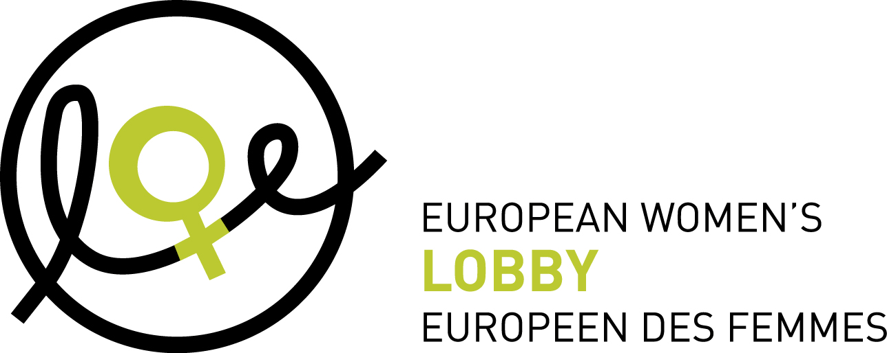

**Membership application for national co-ordinating bodies of the European Women’s Lobby (EWL)**

*This application form should be filled in in all its parts and sent to the European Women’s Lobby by email (**kurz@womenlobby.org**)* ***and*** *by regular mail to:*

***European Women’s Lobby (EWL)***

***18 Rue Hydraulique***

***B-1210 Brussels***

***Belgium***

*For any questions, please do not hesitate to contact the EWL Secretariat (**ewl@womenlobby.org* *or* *kurz@womenlobby.org**)*

*After submitting this application form, including annexes, the EWL Executive Committee will seek the advice of the Membership Committee, and assess whether or not the candidate national co-ordination is meeting the membership criteria as set out in EWL statutes.*

*The Executive Committee is entitled to ask the applicant for any additional information it deems necessary in order to issue its advice to the Board of Administration. If this body asks for any such additional information, the application procedure will be suspended until this additional information is communicated by the applicant (Art. 3 EWL Internal Rules). Additional information may also be obtained through interviews with the applicants.*

*Membership of full members takes effect following a positive vote of the Board of Administration, instructed by the Executive Committee with a two third majority of cast votes (Art. 8 EWL Statutes)*

**This form was updated by the EWL Membership Committee in summer 2017 and changes were approved by the EWL Board of Administration at the 7-8 October 2017 Board Meeting.**

*--------------------------------------------------------------------------------------------------------------------------*

**A. General Information**

1. **Name of the candidate national co-ordination (in English and in the national language, according to the Legal statute of the national co-ordination):[1]**
2. **National coordination legal entity number and year of registration**:

*If not applicable, person completing the form will declare that in a maximum of 3 years she will register legally the entity in the country of coordination or give the reason why the coordination cannot be legally registered.*

1. **Contact details of the lead organisation/contact point for the candidate national co-ordination:**

|  |  |
| --- | --- |
| Name of person responsible for this process |  |
| Email of person responsible for this process |  |
| Street and number of organisation |  |
| Postal code of organisation |  |
| City of organisation |  |
| Country of organisation |  |
| Telephone of organisation |  |
| General email |  |
| Website of organisation |  |

1. **Bank account details:**

|  |  |
| --- | --- |
| Name of account holder |  |
| Address of account holder |  |
| Account number |  |
| Name of bank |  |
| Address of bank |  |
| Code IBAN (International Bank Account Number) |  |
| SWIFT Code or BIC |  |

1. **Please list the women’s NGOs, and women’s sections of mixed NGOs that are members of the candidate national co-ordination and their addresses/contact details.**

**B. Mission and Objectives of the candidate Co-ordination**

1. **Please describe the mission and objectives of the candidate national co-ordination.**
2. **Commitments to promoting Equality between women and men**

The candidate national co-ordination and its members have demonstrated a support for the Convention on the Elimination of All Forms of Discrimination against Women (CEDAW) and its Optional Protocol.

The candidate national co-ordination and its members have demonstrated a support for the Beijing Platform for Action and support EWL Beijing +20 Report “From Words to Action”

The candidate national co-ordination and its members agree with EWL Strategic Framework 2016-2020

The candidate national co-ordination accepts EWL’s purpose and aims and its key policy statements and joint declarations as decided by the General Assembly.

The candidate national co-ordination is informed on all the principles of EWL’s Charter on Violence against women, as laid out in the EWL Charter of Principles adopted in 2007, reiterated in EWL 2016 factsheet on violence against women, and aligned with the EWL Position paper “Towards a Europe Free from All Forms of Male Violence against Women” adopted in 2010.

We confirm that the candidate national co-ordination acts independently of any political party or religious authority.

1. **If you already have a plan of activities for the coming year, even a preliminary one, please describe its main elements, or send a copy with this application:**

**C. Democratic Structure and Functioning of the candidate Co-ordination**

1. **Please describe the agreed internal structures and functioning of the candidate national co-ordination** (i.e. are there Annual meetings for all members, does the co-ordination have a Board, a Steering committee, etc?)
   1. **Please describe how the candidate national co-ordination is representative of a broad range of women’s organisations across the whole of the member state/country**
   2. **Please describe how the needs and perspectives of the many women that face multiple discrimination, including women of different ages, races or ethnic origins, religions or beliefs, abilities, and sexual orientation (this list is not exclusive) are integrated** (ex: are minority women’s associations included in the co-ordination, special working groups, quotas, etc.)
2. **Membership: Please describe the procedure for how the candidate national co-ordination deals with applications from women’s associations that wish to join?**
3. **What are the procedures for electing representatives to the EWL General Assembly and EWL Board of Administration?**
4. **Please describe how the candidate national co-ordination of EWL ensures democratic consultation procedures involving all its members in relation to EWL policy positions and work**
5. **Please describe how the candidate national co-ordination of EWL ensures information dissemination among all its members.**
6. **Please describe the tasks of the organisation acting as a lead agency/secretariat for the candidate national co-ordination and explain whether this role will rotate.**

**The candidate national co-ordination applying as full member agrees to pay the annual membership fee (currently at 1000,00 EUR).**

**The candidate national co-ordination applying as full member accepts EWL Statutes and Internal Rules.**

**Date:**

**Signature:**

(of person responsible of the lead organisation/ contact point for the candidate national co-ordination)

***Please enclose the following annexes:***

*- the statutes of the applicant’s organisation in the original language of the organisation* ***or*** *the Protocol of cooperation signed by those women's NGOs and women's sections of mixed NGOs in the Member State concerned and which exist or are in the process of forming a national coordination, with the view to establishing legal status, recognized by national or international law;*

*- the work programme of the applicant’s organisation or their charter;*

*- a list of the members of the applicant and of their addresses;*

*- a document in which the applicant demonstrates its commitment to the policy objectives of the Association, as referred to in Article 5 of the Statutes.*

**DATA PROTECTION**

The European Women’s Lobby (EWL) is committed to fully comply with the European General Data Protection Regulation (GDPR). The information collected in this document is to ensure the EWL Governing bodies and EWL Secretariat have all the necessary information to review and process the membership application. The information you share with us via this document will not be sold nor shared with anyone outside of the EWL. If at any point you wish to have this document deleted from the EWL files at the Secretariat in Brussels, you can contact us at ewl@womenlobby.org with a request specific to the membership application.

1. If the national co-ordination is not registered legally, it should state the maximum of 3 years from admission.